#____ Name :_______________________________________ Date Assigned: 03/10/16

PLEASE KEEP THIS PAPER FOR FUTURE REFERENCE!

Bottle Buddy Biography Project *Due Date: Tuesday, 03/22/16

Many famous people of California have made significant contributions to the history of our nation and to the state of California. These Americans, entertainers, athletes, scientists, singers, statesmen, women, heroes, great explorers, and others have all made California their home. They include California historical figures, celebrities, and those individuals of California who have influenced the lives of others.

This project requires you to complete 3 parts:
Part 1: Research a famous person from California (with the qualities described above)
Part 2: Write a Biography Riddle (Handout)
Part 3: Make a Bottle Buddy

Part 1 - Research a famous person from California and learn more about your person. First, read to find out some basic facts of the person's life. (on-line, books, biographies, articles, etc.) Think about what else you would like to know about the person and what parts of his/her life you would like to learn more about.

The questions below are for you to reflect as you do your research. The answers to these questions do not need to be written out:
- What makes this person special or interesting?
- What kind of positive impact did he/she have that makes him/her famous?
- How did he/she influence the lives of others?
- What are the adjectives you would most use to describe the person?
- What examples from their life illustrate those qualities?
- What events shaped or changed this person's life?
- Did he or she overcome any obstacles or hardships? Take risks?
Part 2 - Create a biography riddle: Who AM I? (Handout) Include at least 8 clues to help others understand more about your person. Type or write your clues neatly with a pen. Write about clues that people may or may not know about. Here’s an example below:
Who am I?

I was born on September 26, 1981 in Michigan.
I lived in Compton, California with my family.
I started playing tennis when I was three years old.
My father was one of my tennis coaches.
I am five feet 9 inches tall.
I won 4 Olympic gold medals.
I am currently ranked Number 1 in Women’s Singles Tennis.
I was named as Sportsperson of the Year by Sports Illustrated in 2015.
I am fluent in French and I also speak a little Spanish.
I have a foundation that helped build schools in Africa.
I have a sister named Venus.
Who am I?

Answer: Serena Williams

Riddle written by: Sample Kang

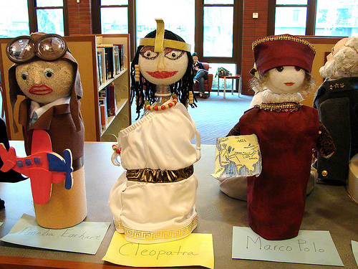
Part 3 - Make a Bottle Buddy Use a 2-liter plastic bottle for the body and a 4” Styrofoam ball (found at Michaels, Hobby Lobby, Wal-Mart or other craft stores) for the head. Fill the bottom with 2 inches of sand or dirt. (Sand in the bottom will help it to stand.) Make the bottle look like your person. To make your bottle like your person use any material available: felt, paint, fabric, rocks, sticks, hats, construction paper, aluminum foil, etc. to create their costume and props. If you have any extra bottles or supplies, please bring them in to share with other students who may be in need! Have fun and be creative.

You can view some photos of Bottle Buddies on my website: www.mrskang.weebly.com. Go to Bottle Buddy Project Tab.

Bring your Bottle Buddy Project to school on Tuesday, March 22, 2016. Be ready to display your Bottle Buddy & the riddle with other students in the classroom. We will have an activity to showcase all the Bottle Buddies in class.

Please sign and return the bottom part of this paper ASAP. All students will need the final approval from the teacher before starting their project. Priority will be given to the students who bring in their tear-off slips early.

Thank you,
Mrs. Kang

------------- Please cut & return this bottom portion to Mrs. Kang NO LATER THAN Tuesday, 03/15/16 ------------

We have read & reviewed the above information regarding the Bottle Buddy project. My child knows that the Bottle Buddy project is due NO LATER than Tuesday, March 22, 2016. All Bottle Buddy projects from room B11 will be on display at Open House on March 24, 2016.

* My choice of a Famous Person from California:

1st choice: ___________________________________________________________________

2nd choice: ___________________________________________________________________

3rd choice: ___________________________________________________________________

Parent Signature: X_________________________________________________________________________

Student Name: _______________________________________________________________ # _______

